Orator’s Report
on the 32nddegree
Master of the
Royal Secret
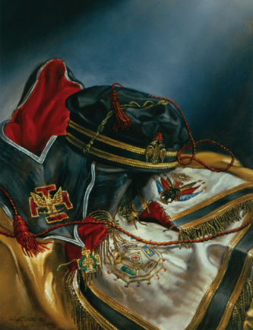
May 27, 2021

The apron is white bordered with two stripes of gold lace.
Six flags are embroidered on the flap. Above is a
gold Teutonic double-headed eagle cross.
The reverse of the apron is crimson.
Bremerton Valley of the Scottish Rite

The Legend: The Consistory comprises the 31st and 32nd Degrees. The word consistory derives from the Latin consistorium, which means both "tribunal" and "imperial council." As with other degrees of Freemasonry, the consistorial degrees presents some of their lessons by borrowing the ancient legends and symbols of other cultures and times including European, Hebrew, Persian, and Brahman/Hindu religions and philosophies (see 24th °). Some of the most profound truths of the ancient mysteries are spoken as axioms. You are called upon to summon your greatest capacities, and attempt to pierce the veil of the symbolic language in which they are presented. To be truly a Master of the Royal Secret individual realization is required on the part of each and every initiate.
The Setting: The 32nd degree is set in the Templar Consistory Council Chamber during the Crusader period; which began in 1099 with the First Crusade's capture of Jerusalem. After the city's conquest, the Knights Templar were granted use of the captured Al-Aqsa Mosque on the Temple Mount for their headquarters and although not mentioned in the degree, it is assumed that is the degree site. The Temple Mount had a mystique because it was above what were believed to be the ruins of the Temple of Solomon. The Crusaders therefore referred to the Al-Aqsa Mosque as Solomon's Temple, and it was from this location that the new Order took the name of "Poor Knights of Christ and the Temple of Solomon".
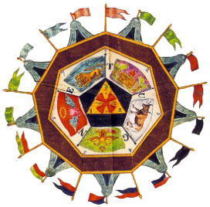
The Ritual: In the first section of
the degree the aspirant is reintroduced to the all the degrees symbolized by the Camp, which is a series of tents representing encampments of Masons arranged in a particular order according to the degree being represented.
In the second section the aspirant consents to five vows, marking him as a Soldier of Light, Liberty, Freedom of Religion, the People, and of Scottish Rite Masonry. He is advised that the vows are not idle ceremony and warned that he will be expected to keep the promises made. He is invested with the cordon, jewel, signs, and words of the degree and is bestowed with the Royal Secret.
The Lecture: “Yin - Yang” is an ancient concept of dualism, describing how seemingly opposite or contrary forces may actually be complementary, interconnected, and interdependent in the natural world, how they may give rise and interrelate to each other, and how they may reach equilibrium. Similar concepts are found in many ancient philosophies. Interpreted by Persians and Hindus alike, these teachings are presented as they were expressed thousands of years ago by the ancients. These primitive philosophies passed eastward and westward and fertilized the cultural traditions of most of the world. The Moral Code of Masonry is still more extensive than that developed by philosophy. It adds the obligation of a contract.
The Royal Secret is Equilibrium; not a secret in the ordinary sense of the word, but a mystery; A mystery acknowledged by the world's greatest philosophers and teachers. As we begin to recognize the Divine Presence both in our consciousness, and in our physical lives, we also begin to understand that our goal of Equilibrium will in fact come from becoming the reflection of the Divine Being.
Authority is the equilibrium of Liberty and Power. Wisdom is equilibrium in the Thoughts. Virtue is equilibrium in the Affections, even the colors in the Light only exist by the presence of the shadow. Equilibrium is in the Deity, between the infinite divine wisdom and the infinite divine power. Equilibrium must exist between justice and mercy, necessity and liberty, authority and individual action which constitutes free government, and equilibrium must exist in ourselves, which Masonry demands of its members, between the spiritual and divine and the material and human in man; between the intellect, reason, and moral sense on one side, and the appetites and passions on the other, from which result the harmony and beauty of a well-regulated life.

The lesson of this degree is that Equilibrium teaches us to have respect and charity for others who are partakers with us of the Divine Nature, lighted by a ray of the Divine Intelligence, capable, like us, of progress upward toward perfection, and deserving to be loved not hated, to be aided and encouraged in this life-struggle and not to be abandoned or to be trampled upon in our own efforts to ascend.
DUTIES:
A Soldier of Light seeks and teaches truth and knowledge.
A Soldier of Freedom demands that all the people have free vote and voice.
A Soldier of True Religion fights spiritual tyranny with reason and truth.
A Soldier of the People encourages all people to be self-reliant and independent.
A Freemasonry Soldier is zealous and ardent in the performance of his duties to God, country, family, Brothers, and himself.
LESSONS: The human is always intertwined with the Divine. Only doctrines, faith, or knowledge that act are of value. To work is to adore. The motto of this Degree:
“Spes mea in Deo est,” which means “My hope is in God.”
TO REFLECT: Are you striving to achieve the Royal Secret in your life and within yourself?
IMPORTANT SYMBOLS: The Camp, Tetractys minor, five-pointed star, seven-pointed star Tetractys major, triple interlocking triangles, Trimurti (3-sided bust).
The apron is of white silk or velvet, the reverse is crimson.The cordon is worn from the right shoulder to the left hip edged with black with white on the main side and crimson on the other. A red Teutonic cross with a superimposed silver double-headed eagle is embroidered on the tip of the main side. On the crimson side a Teutonic cross is embroidered in black. The jewel of the order is a gold Teutonic cross with frosted arms. At center are the letters "XXXII", in a green wreath.
Adapted from Rex R. Hutchen’s book A Bridge to Light

